## MINI PROJECT

(2020-21)

Website Development

MID-TERM REPORT



Institute of Engineering & Technology

Submitted By:-

SACHIN GUPTA(181500599)

ASHISH CHAUDHARY(181500140)

ABHISHEK PANDEY(181500020)

ARUN PRATAP SINGH(181500132)

Supervised By:-

Ms. Priya Agarwal

Trainer

Department of Computer Engineering & Applications

Contents

Abstract

1.Introduction

1.1 General Introduction to the topic

1.2 Area of Computer Science

1.3 Hardware & Software Requirements

2. Problem definition

3. Objectives

4. Implementation Details

5. Progress till Date & The Remaining work

6. Some Screenshots

7. References

ABSTRACT : This thesis project consists of the development of a contributory web application to display and gather information on Web Development . The goal of this application is to create the foundation for a web-based spatial inventory of existing . The inventory is meant to advise policymakers and heritage organizations on priority resources to protect the existing base of resources as well as to create a historic record of the historic urban landscape. This is important because the push to modernize infrastructure in emerging nations often leads to the destruction of the colonial heritage fabric in urban areas. An inventory of what currently exists, and possibly what existed in the past, will help to digitally record these sites. As a secondary purpose, the web application was developed to be replicable by others who might choose to take and adapt the web application model for their own heritage conservation-related purposes. As such, the web application employs easy-to-use, relatively inexpensive, cloud-based tools and services, such Persona, Heroku, Bitbucket, and various Google products. In order to use many of these services together, the web application was purposebuilt using the well-documented and flexible Python web development framework, in conjunction with the templating system, along with the standard HTML, CSS, and JavaScript programming languages. After instructional documentation is written and further development occurs as specified in the application’s roadmap, the code, which is currently stored in a private repository on Bitbucket will be opened for download and collaboration by others wanting to use and improve the application model.

**Introduction to Web Development**

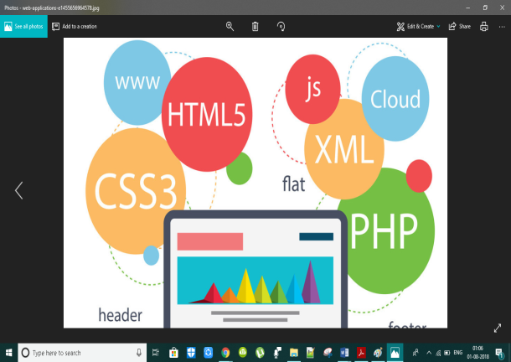

**What is Web Development?**

Web development is the coding or programming that enables website functionality, per the owner's requirements. It mainly deals with the non-design aspect of building websites, which includes coding and writing markup.

Web development ranges from creating plain text pages to complex web-based applications, social network applications and electronic business applications.

The web development hierarchy is as follows:

* Client-side coding
* Server-side coding
* Database technology

Among web professionals, "web development" usually refers to the main non-design aspects of building web sites: writing [markup](https://en.wikipedia.org/wiki/Markup_language) and [coding](https://en.wikipedia.org/wiki/Computer_programming). Web development may use [content management systems](https://en.wikipedia.org/wiki/Content_management_system) (CMS) to make content changes easier and available with basic technical skills.

For larger organizations and businesses, web development teams can consist of hundreds of people ([web developers](https://en.wikipedia.org/wiki/Web_developer)) and follow standard methods like [Agile methodologies](https://en.wikipedia.org/wiki/Agile_software_development) while developing websites. Smaller organizations may only require a single permanent or contracting developer, or secondary assignment to related job positions such as a [graphic designer](https://en.wikipedia.org/wiki/Graphic_designer) or [information systems](https://en.wikipedia.org/wiki/Information_systems) technician. Web development may be a collaborative effort between departments rather than the domain of a designated department. There are three kinds of web developer specialization: [front-end developer](https://en.wikipedia.org/wiki/Front-end_web_development), back-end developer, and [full-stack developer](https://en.wikipedia.org/wiki/Full-stack_developer). Front-end developers responsible for behavior and visuals that run in the user browser, while back-end developers deal with the servers.

A basic website or may be a highly professional website have two ends :

* Front End – User Interface
* Back End – Website Functionality

**Basic Languages used in Front end development**

* HTML
* CSS
* Bootstrap

**Basic Languages used in back end development**

* SQL
* PHP

**What is Front End Web development ?**

Front-end web development, also known as client-side development is the practice of producing HTML, CSS and JavaScript for a website or Web Application so that a user can see and interact with them directly. The challenge associated with front end development is that the tools and techniques used to create the front end of a website change constantly and so the developer needs to constantly be aware of how the field is developing.

The objective of designing a site is to ensure that when the users open up the site they see the information in a format that is easy to read and relevant. This is further complicated by the fact that users now use a large variety of devices with varying screen sizes and resolutions thus forcing the designer to take into consideration these aspects when designing the site. They need to ensure that their site comes up correctly in different browsers (cross-browser), different operating systems (cross-platform) and different devices (cross-device), which requires careful planning on the side of the developer.

A front-end developer architects and develops websites and applications using web technologies (i.e., [HTML](https://developer.mozilla.org/en-US/docs/Web/HTML), [CSS](https://developer.mozilla.org/en-US/docs/Web/CSS), [DOM](https://developer.mozilla.org/en-US/docs/Web/API/Document_Object_Model), and [JavaScript](https://developer.mozilla.org/en-US/docs/Web/JavaScript)), which run on the [Open Web Platform](https://en.wikipedia.org/wiki/Open_Web_Platform) or act as compilation input for non-web platform environments.

Typically, a person enters into the field of front-end development by learning to develop HTML, CSS, and JavaScript which commonly runs in a [web browser](https://en.wikipedia.org/wiki/Web_browser) but can also run in a [headless browser](https://en.wikipedia.org/wiki/Headless_browser), [WebView](http://developer.telerik.com/featured/what-is-a-webview/), or as compilation input for a native runtime environment.

**What is HTML ?**

**Hypertext Markup Language** (**HTML**) is the standard [markup language](https://en.wikipedia.org/wiki/Markup_language) for documents designed to be displayed in a [web browser](https://en.wikipedia.org/wiki/Web_browser). It can be assisted by technologies such as [Cascading Style Sheets](https://en.wikipedia.org/wiki/Cascading_Style_Sheets) (CSS) and [scripting languages](https://en.wikipedia.org/wiki/Scripting_language) such as [JavaScript](https://en.wikipedia.org/wiki/JavaScript).

**What is CSS ?**

Cascading Style Sheets (CSS) is a [style sheet language](https://en.wikipedia.org/wiki/Style_sheet_language) used for describing the [presentation](https://en.wikipedia.org/wiki/Presentation_semantics) of a document written in a [markup language](https://en.wikipedia.org/wiki/Markup_language) like [HTML](https://en.wikipedia.org/wiki/HTML). CSS is a cornerstone technology of the [World Wide Web](https://en.wikipedia.org/wiki/World_Wide_Web), alongside HTML and [JavaScript](https://en.wikipedia.org/wiki/JavaScript).

**What is Bootstrap ?**

**Bootstrap** is a [free and open-source](https://en.wikipedia.org/wiki/Free_and_open-source) [CSS framework](https://en.wikipedia.org/wiki/CSS_framework) directed at responsive, mobile-first [front-end web development](https://en.wikipedia.org/wiki/Front-end_web_development). It contains [CSS](https://en.wikipedia.org/wiki/CSS)- and (optionally) [JavaScript](https://en.wikipedia.org/wiki/JavaScript)-based design templates for [typography](https://en.wikipedia.org/wiki/Web_design#Typography), [forms](https://en.wikipedia.org/wiki/Form_(HTML)), [buttons](https://en.wikipedia.org/wiki/Button_(computing)#HTML), [navigation](https://en.wikipedia.org/wiki/Web_navigation#Local_website_navigation) and other interface components.

Bootstrap, originally named Twitter Blueprint, was developed by Mark Otto and Jacob Thornton at [Twitter](https://en.wikipedia.org/wiki/Twitter) as a framework to encourage consistency across internal tools. Before Bootstrap, various libraries were used for interface development, which led to inconsistencies and a high maintenance burden.

**What is Back End Web Development ?**

So what makes the front end of a website possible? Where is all that data stored? This is where the back end comes in. The back end of a website consists of a server, an application, and a database. A back-end developer builds and maintains the technology that powers those components which, together, enable the user-facing side of the website to even exist in the first place.

***SKILLS AND TOOLS***

In order to make the server, application, and database communicate with each other, back-end devs use server-side languages like PHP, Ruby, Python, Java, and .Net to build an application, and tools like MySQL, Oracle, and SQL Server to find, save, or change data and serve it back to the user in front-end code. Job openings for back-end developers often also call for experience with PHP frameworks like Zend, Symfony, and CakePHP; experience with version control software like SVN, CVS, or Git; and experience with Linux as a development and deployment system.

Back-end devs use these tools to create or contribute to web applications with clean, portable, well-documented code. But before writing that code, they need to collaborate with business stakeholders to understand their particular needs, then translate those into technical requirements and come up with the most effective and efficient solution for architecting the technology.

**What is MySQL?**

**SQL** ( **Structured Query Language**) is a [domain-specific language](https://en.wikipedia.org/wiki/Domain-specific_language) used in programming and designed for managing data held in a [relational database management system](https://en.wikipedia.org/wiki/Relational_database_management_system) (RDBMS), or for stream processing in a [relational data stream management system](https://en.wikipedia.org/wiki/Relational_data_stream_management_system) (RDSMS). It is particularly useful in handling [structured data](https://en.wikipedia.org/wiki/Data_model)where there are relations between different entities/variables of the data. SQL offers two main advantages over older read/write [APIs](https://en.wikipedia.org/wiki/API) like [ISAM](https://en.wikipedia.org/wiki/ISAM) or [VSAM](https://en.wikipedia.org/wiki/VSAM). First, it introduced the concept of accessing many records with one single command; and second, it eliminates the need to specify *how* to reach a record, e.g. with or without an [index](https://en.wikipedia.org/wiki/Database_index).

**What is PHP?**

**PHP: Hypertext Preprocessor** (or simply **PHP**) is a [general-purpose programming language](https://en.wikipedia.org/wiki/General-purpose_programming_language) originally designed for [web development](https://en.wikipedia.org/wiki/Web_development). It was originally created by [RasmusLerdorf](https://en.wikipedia.org/wiki/Rasmus_Lerdorf) in 1994; the PHP [reference implementation](https://en.wikipedia.org/wiki/Reference_implementation) is now produced by The PHP Group. PHP originally stood for *Personal Home Page*, but it now stands for the [recursive initialism](https://en.wikipedia.org/wiki/Recursive_initialism) *PHP: Hypertext Preprocessor*.

PHP code may be executed with a [command line interface](https://en.wikipedia.org/wiki/Command-line_interface) (CLI), embedded into [HTML](https://en.wikipedia.org/wiki/HTML) code, or used in combination with various [web template systems](https://en.wikipedia.org/wiki/Web_template_system), web [content management systems](https://en.wikipedia.org/wiki/Content_management_system), and [web frameworks](https://en.wikipedia.org/wiki/Web_framework). PHP code is usually processed by a PHP [interpreter](https://en.wikipedia.org/wiki/Interpreter_(computing)) implemented as a [module](https://en.wikipedia.org/wiki/Plugin_(computing)) in a web server or as a [Common Gateway Interface](https://en.wikipedia.org/wiki/Common_Gateway_Interface) (CGI) executable. The web server outputs the results of the interpreted and executed PHP code, which may be any type of data, such as generated HTML code or binary image data. PHP can be used for many programming tasks outside of the web context, such as [standalone](https://en.wikipedia.org/wiki/Computer_software) [graphical applications](https://en.wikipedia.org/wiki/Graphical_user_interface) and robotic [drone](https://en.wikipedia.org/wiki/Unmanned_aerial_vehicle) control.

**Hardware Requirements**

* 2.0 GHz processor for faster processing power.
* 1 GB RAM
* 2-3 GB Hard Disk Storage
* OS : Windows, MacOS or Linux

**Software Requirements**

* Sublime text editor
* JQuery, Bootstrap – for the front end &
* WAMP server – To handle communication with Website and to store data from the website

**INTRODUCTION TO PROJECT**

Through the six week of the training program, I have been working on a creating some website landing pages. There are of 2 different HTML pages. The website will consist of HTML, CSS, BOOTSTRAP, PHP and MYSQLI code. The HTML, CSS and BOOTSTRAP part of your code decides how your website will look, while the PHP and MySQL part decides how it will function. There are 2 major tasks during this program. They will be structured as follows :

1) HTML , CSS AND BOOTSTRAP : where I have design the look of each page of your website.

2) PHP &MySQL: where I willadd functionality to the website. This will allow you to allow users to register and buy flowers on the website.

The main pages that need to be designed are:

1. Blog page
2. Startup Landing page

**Working**

**HTML code for blog page**

<!DOCTYPE html>

<html>

<head>

<title>blog</title>

<link rel="stylesheet" type="text/css" href="blog.css">

</head>

<link href="https://fonts.googleapis.com/css?family=Source+Sans+Pro:400,700&display=swap" rel="stylesheet">

<body>

<div class="date">JUNE 13 2019</div>

<div class="heading"><h2>This Is My First Article</h2></div>

<div class="quote"><p>Bacon ipsum dolor amet capicola strip steak landjaeger, biltong spare ribs rump cow ground round andouille sirloin pork. Short ribs pig prosciutto swine. Flank turducken turkey rump, leberkas shoulder bresaola ham hock tail drumstick corned beef. Venison pork chop beef jowl short ribs.</p></div>

<p>Bresaola short ribs pastrami, beef ribs spare ribs kielbasa ham tongue kevin landjaeger chicken ball tip. Pork chop beef kevin strip steak, chicken pork belly pastrami ham hock flank shoulder chuck turkey ribeye andouille ball tip. Leberkas ham ham hock pork loin. Filet mignon bacon pancetta leberkas turducken fatback tongue frankfurter jowl. Shoulder tenderloin chicken shank bacon shankle sirloin.</p>

<p>Pork pig pork loin prosciutto meatball turkey beef ribs ground round. Pork belly salami shank pork chop turducken ribeye swine shoulder tri-tip fatback cupim short loin chuck strip steak. Rump pork chop t-bone.</p>

<hr>

<div class="date">AUGUST 15 2019</div>

<div class="heading"><h2>This Is Another Article</h2></div>

<div class="quote"><p>Bacon ipsum dolor amet capicola strip steak landjaeger, biltong spare ribs rump cow ground round andouille sirloin pork. Short ribs pig prosciutto swine. Flank turducken turkey rump, leberkas shoulder bresaola ham hock tail drumstick corned beef. Venison pork chop beef jowl short ribs.</p></div>

<p>Shankle beef ribs tongue strip steak flank landjaeger capicola hamburger chuck pancetta kevin. Sirloin landjaeger chicken, bresaola brisket swine short ribs turkey short loin ball tip porchetta ham hock. Capicola frankfurter jowl short loin. Kevin flank hamburger, beef venison shankle short loin bresaola frankfurter</p>

<p>Bresaola short ribs pastrami, beef ribs spare ribs kielbasa ham tongue kevin landjaeger chicken ball tip. Pork chop beef kevin strip steak, chicken pork belly pastrami ham hock flank shoulder chuck turkey ribeye andouille ball tip. Leberkas ham ham hock pork loin. Filet mignon bacon pancetta leberkas turducken fatback tongue frankfurter jowl. Shoulder tenderloin chicken shank bacon shankle sirloin.</p>

</body>

</html>

**CSS code for blog page**

body{

border: 20px solid #bdc3c7;

margin:20px auto;

max-width: 700px;

width: 80%;

padding:20px;

font-family: Source Sans Pro ;

padding-bottom: 10px;

}

.heading {

color:#2c3e58;

font-size: 2rem;

}

.quote{

border-left: 5px solid #bdc3c7;

padding-left: 2px;

}

.date{

text-transform: uppercase;

letter-spacing: 5px;

color: #3498db;

font-weight: bold;

}

hr {

border: 0;

height: 1px;

background-image: -webkit-linear-gradient(left, #f0f0f0, #8c8b8b, #f0f0f0);

background-image: -moz-linear-gradient(left, #f0f0f0, #8c8b8b, #f0f0f0);

background-image: -ms-linear-gradient(left, #f0f0f0, #8c8b8b, #f0f0f0);

background-image: -o-linear-gradient(left, #f0f0f0, #8c8b8b, #f0f0f0);

}

**Output**

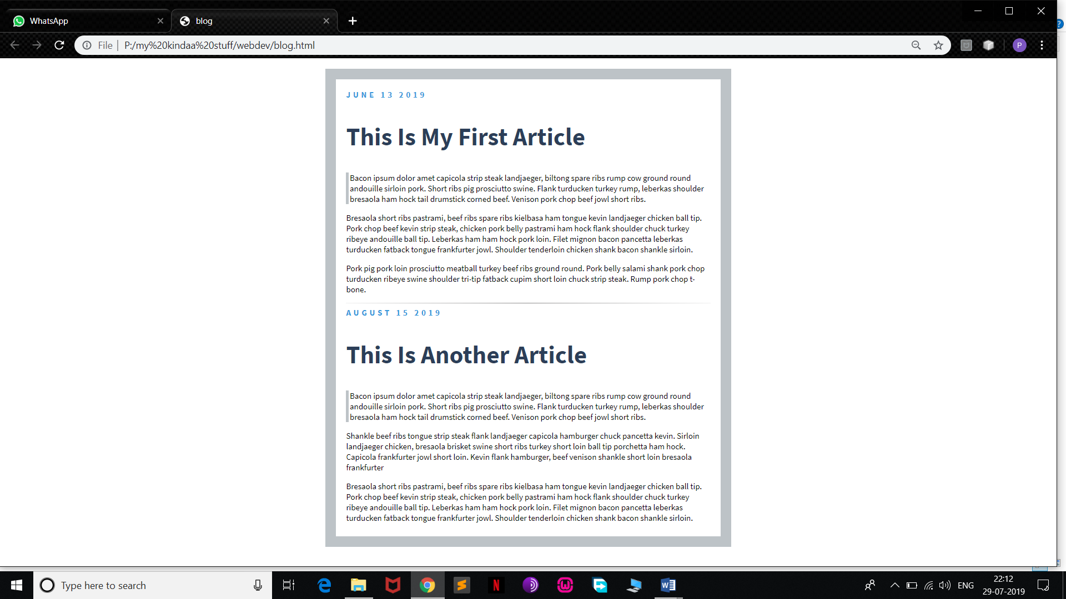

**HTML code for Startup landing page**

<!DOCTYPE html>

<html>

<head>

<title>Image Gallery</title>

<link rel="stylesheet" href="https://maxcdn.bootstrapcdn.com/bootstrap/3.3.7/css/bootstrap.min.css" integrity="sha384-BVYiiSIFeK1dGmJRAkycuHAHRg32OmUcww7on3RYdg4Va+PmSTsz/K68vbdEjh4u" crossorigin="anonymous">

<link rel="stylesheet" href="https://maxcdn.bootstrapcdn.com/font-awesome/4.4.0/css/font-awesome.min.css">

<link rel="stylesheet" type="text/css" href="image gallery.css">

</head>

<body>

<nav class="navbar navbar-inverse navbar-fixed-top">

<div class="container">

<!-- Brand and toggle get grouped for better mobile display -->

<div class="navbar-header">

<button type="button" class="navbar-toggle collapsed" data-toggle="collapse" data-target="#bs-example-navbar-collapse-1" aria-expanded="false">

<span class="sr-only">Toggle navigation</span>

<span class="icon-bar"></span>

<span class="icon-bar"></span>

<span class="icon-bar"></span>

</button>

<a class="navbar-brand" href="#"><span class="glyphicon glyphicon-picture" aria-hidden="true"></span> IMGS</a>

</div>

<!-- Collect the nav links, forms, and other content for toggling -->

<div class="collapse navbar-collapse" id="bs-example-navbar-collapse-1">

<ul class="nav navbar-nav">

<li class="active"><a href="#">About <span class="sr-only">(current)</span></a></li>

<li><a href="#">Contact</a></li>

</li>

</ul>

<ul class="nav navbar-nav navbar-right">

<li><a href="#">Sign Up</a></li>

<ul class="nav navbar-nav navbar-right">

<li><a href="#">Login</a></li>

</ul>

</div><!-- /.navbar-collapse -->

</div><!-- /.container-fluid -->

</nav>

<div class="container">

<div class="jumbotron">

<h1><i class="fa fa-camera-retro" aria-hidden="true"></i> The Image Gallery</h1>

<p>A bunch of beautiful images that I didn't take( like no one:) )</p>

</div>

<div class="row">

<div class="col-lg-4 col-md-6 col-sm-6">

<div class="thumbnail">

<img src="http://i.imgur.com/qK42fUu.jpg">

</div>

</div>

<div class="col-lg-4 col-md-6 col-sm-6">

<div class="thumbnail">

<img src="https://images.unsplash.com/photo-1435771112039-1e5b2bcad966?dpr=2&fit=crop&fm=jpg&h=825&q=50&w=1450">

</div>

</div>

<div class="col-lg-4 col-md-6 col-sm-6">

<div class="thumbnail">

<img src="https://images.unsplash.com/photo-1442406964439-e46ab8eff7c4?dpr=2&fit=crop&fm=jpg&h=825&q=50&w=1450">

</div>

</div>

</div>

<div class="row">

<div class="col-lg-4 col-md-6 col-sm-6">

<div class="thumbnail">

<img src="https://images.unsplash.com/photo-1439524970634-649c37a69e5c?ixlib=rb-0.3.5&q=80&fm=jpg&crop=entropy&w=1450&h=825&fit=crop&s=bfda9916c885869b43b70738693428d9

">

</div>

</div>

<div class="col-lg-4">

<div class="thumbnail">

<img src="https://images.unsplash.com/photo-1444090542259-0af8fa96557e?dpr=2&fit=crop&fm=jpg&h=825&q=50&w=1450

">

</div>

</div>

<div class="col-lg-4 col-md-6 col-sm-6">

<div class="thumbnail">

<img src="https://images.unsplash.com/photo-1434543177303-ef2cc7707e0d?dpr=2&fit=crop&fm=jpg&h=825&q=50&w=1450

">

</div>

</div>

</div>

<div class="row">

<div class="col-lg-4 col-md-6 col-sm-6">

<div class="thumbnail">

<img src="https://images.unsplash.com/photo-1436262513933-a0b06755c784?dpr=2&fit=crop&fm=jpg&h=825&q=50&w=1450

">

</div>

</div>

<div class="col-lg-4 col-md-6 col-sm-6">

<div class="thumbnail">

<img src="https://images.unsplash.com/photo-1439396087961-98bc12c21176?dpr=2&fit=crop&fm=jpg&h=825&q=50&w=1450

">

</div>

</div>

<div class="col-lg-4 col-md-6 col-sm-6">

<div class="thumbnail">

<img src="https://images.unsplash.com/photo-1439694458393-78ecf14da7f9?dpr=2&fit=crop&fm=jpg&h=825&q=50&w=1450

">

</div>

</div>

</div>

</div>

<script

src="http://code.jquery.com/jquery-3.4.1.js"

integrity="sha256-WpOohJOqMqqyKL9FccASB9O0KwACQJpFTUBLTYOVvVU="

crossorigin="anonymous"></script>

<script src="https://maxcdn.bootstrapcdn.com/bootstrap/3.3.7/js/bootstrap.min.js" integrity="sha384-Tc5IQib027qvyjSMfHjOMaLkfuWVxZxUPnCJA7l2mCWNIpG9mGCD8wGNIcPD7Txa" crossorigin="anonymous"></script>

</body>

</html>

**CSS code for startup landing page**

body{

padding-top: 70px;

}

.jumbotron{

color: #2c3e50;

background:#ecf0f1;

}

.navbar-inverse{

background: #2c3e50;

}

.navbar-inverse .navbar-brand{

color: white;

}

.navbar-inverse .navbar-nav>li>a{

color:white;

}

**Output**

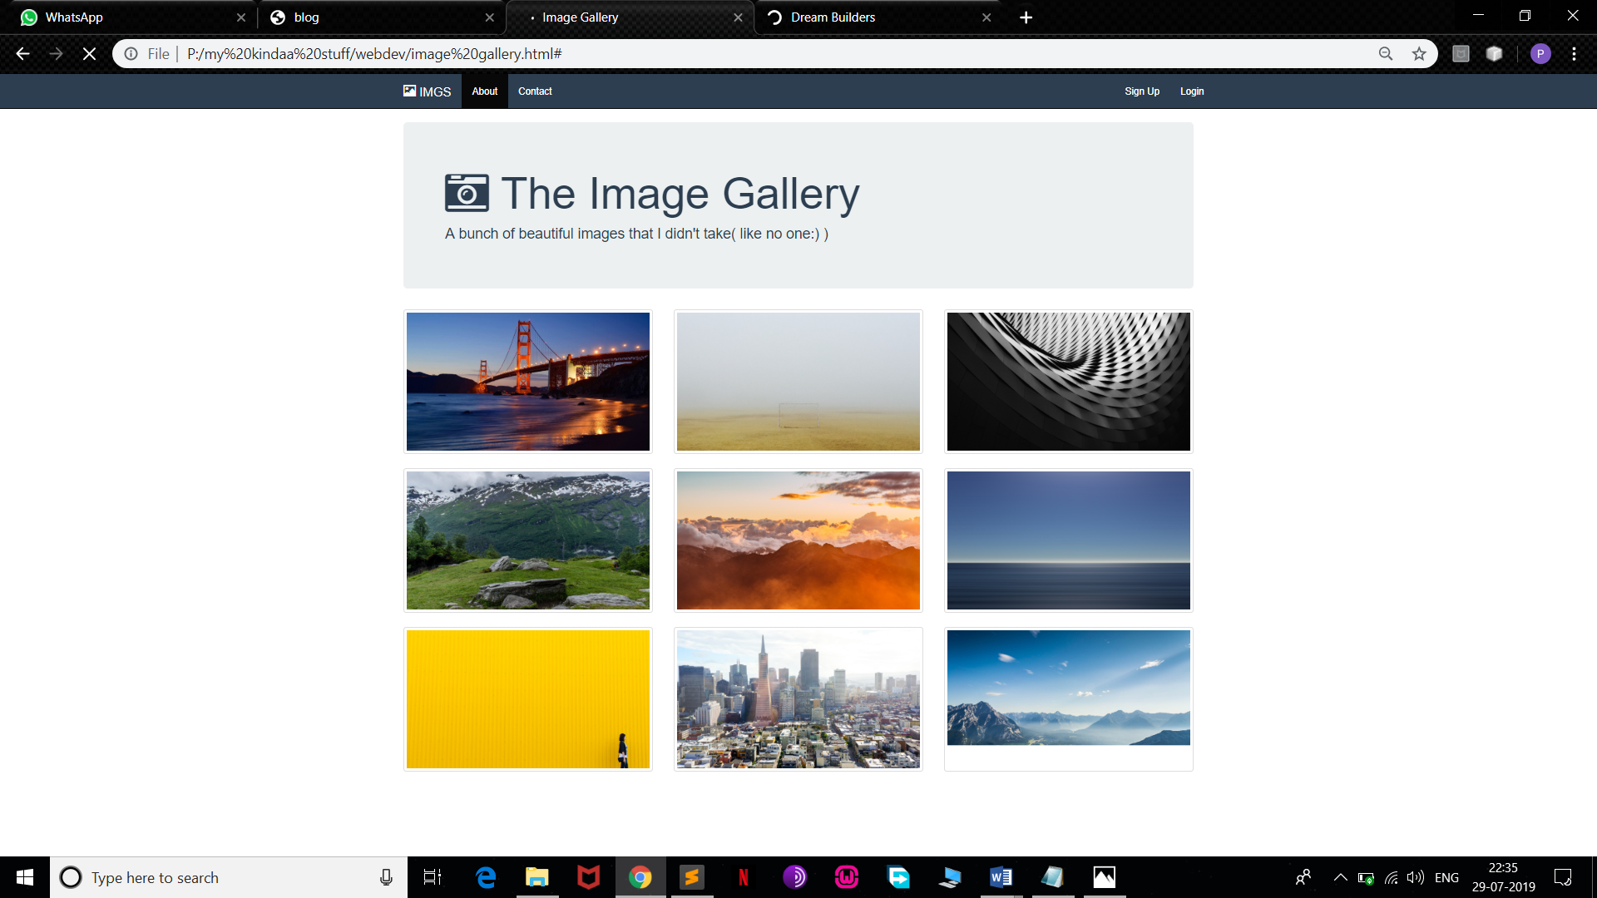

**CONCLUSION**

A Web Development project, This project may seem relatively simple as a Web Development project but I think it shows that I can work well with HTML, CSS and Bootstrap and I think the code is clean, logical and commented to make it clearer to whoever's reading it.

So our website is a very basic implementation of different web developments languages.I will be developing this project further later on and add new features.

Future Plans regarding project:

* Developing back end of this website so that it would be a complete package.
* Using PHP and MYSQL for providing backend stability.

As I said it is a very basic website , it will have some new and exciting features in future.